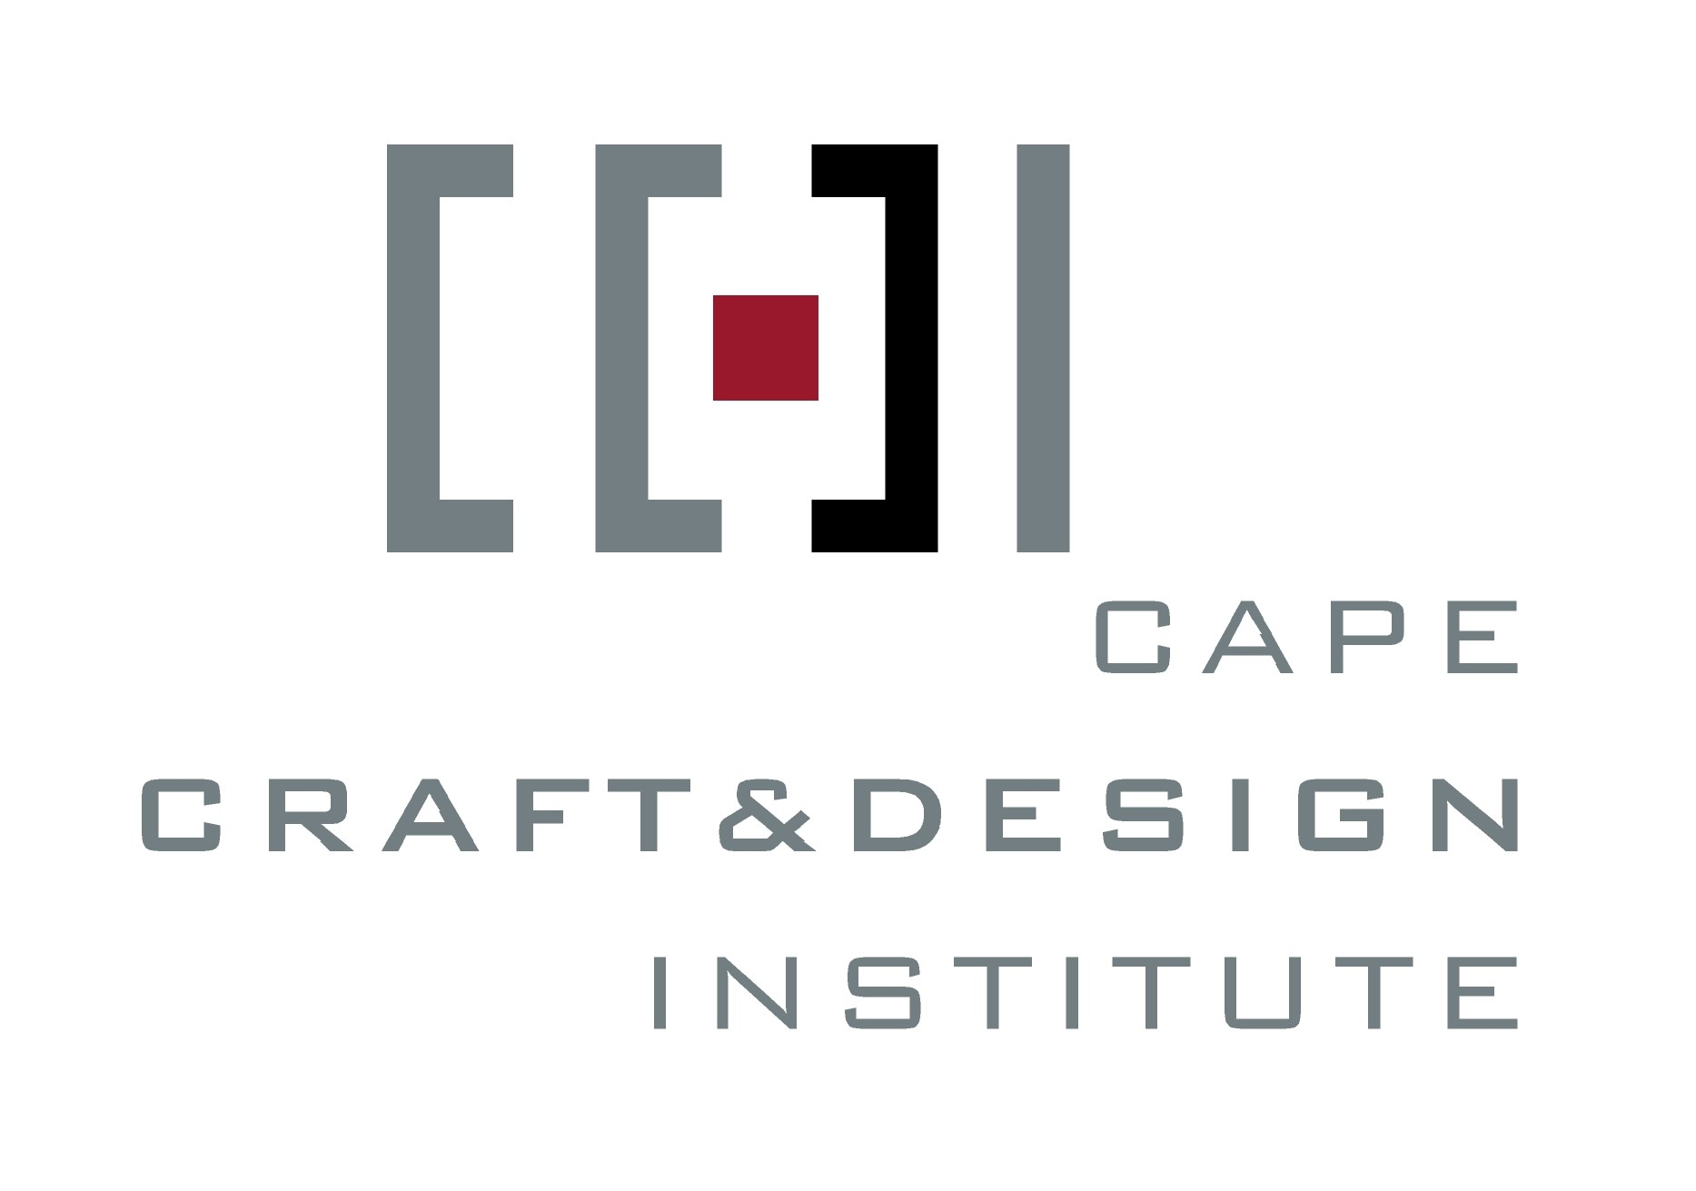

Die Kaapse Instituut vir Handwerk & Ontwerp

FACTSHEET 4

Training Programmes

IZiko Lasekapa Lobuchule Nobugcisa

Room 2.413, Administration Building, Cape Technikon,

P O Box 652, Cape Town, 8000.

Tel: 27 (0)21 460-3982

Fax: 27 (0)21 460-3553

E-mail: ccdi@ctech.ac.za

Together with CreateSA, the Cape Craft & Design Institute is piloting a number of training courses aimed at developing the technical, design, business and marketing skills of craft producers.

NQF4 – Design for Production – pilot 2002

In its first year of operation, the CCDI ran its first pilot MAPPP Seta learnership, together with CreateSA. This was a 6-month course at the Cape Technikon, part of which was full-time, and part consisted of on-going mentoring. The course targeted crafters with established skills, and aimed to enhance their design ability to bring their products to a new level of adjustability to the market and to different fashion and user needs. Twenty-three learners benefited from this course. The lessons learnt from this pilot are being used in the development of a full learnership (NQF4) in Craft Micro-enterprise.

NQF4 – Craft Micro-enterprise – pilot 2003-04

This course aims to build on the experience of the Design for Production course. It will run over a one-year period and incorporate business skills together with design skills. The crafters selected are mostly individual entrepreneurs and have had many years of experience in craft production. Once again part of the course will be presented on a full-time basis, using the facilities of the Design Faculty at the Cape Technikon, while certain modules will be executed in the crafter’s own work environment. On-going mentoring in both design, production, business and marketing skills will be done.

NQF5 – Exhibition Design, Management & Installation – pilot 2003

Leading up to the world [piece] craft exhibition, the Institute piloted a skills development programme in Exhibition Design, Installation and Management, together with CreateSA. This course was presented at a NQF5 level. It will form the basis of an elective in a full NQF5 Level Learnership called Craft Operations Management

Fourteen students were trained in various facets of exhibition design, execution, sourcing material, managing the logistics of an exhibition, and practical installation. They were then practically exposed to working with the designer, Nicholas de Klerk, in setting up the world [piece] exhibition, which covered more than 1000 m2.

See over/….

Resource Development Programme

Through the implementation of the above programmes, as well as through targeted and applied research, the Institute aims to develop resource materials for the sector.

The Resource Development Programme will draw on these two main components:

- Training – through learnerships, skills development courses and a seminar series, the Institute will develop training courses to enhance the skills of producers and equip them for business growth
- Research – the location of the Institute at the Cape Technikon provides a unique opportunity to build partnerships between the tertiary institution and the sector. Together with the Faculty of Built Environment & Design, the Institute will develop targeted and applied research programmes that will maximise the input of students, lecturers, and other training institutions and providers into the sector.

For further information contact: Erica Elk, Project Director, Cape Craft & Design Institute. Tel: 021 460-3982 / ccdi@ctech.ac.za

CreateSA

For further information on CreateSA contact: Dawn Robertson on 011 794-3810/ dawnrobertson@artslink.co.za ; or Ramzie Abrahams on 021 949-1463/ westernregion.createsa@artslink.co.za

